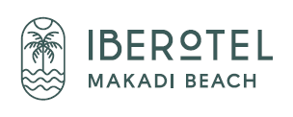
WhatsApp +20 (0) 12 1119 1407

Kindly scan the below QR code
For Hotel Info
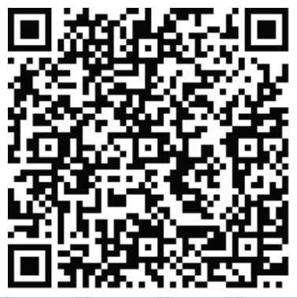
RESTAURANTS
El Sayadeia Main Restaurant
- Continental Breakfast 05h00 – 07h00
- Breakfast Buffet (daily flash newspaper) 07h00 – 10h30
- Lunch (Light Buffet) 12h30 – 14h30
- Dinner Buffet 18h30 – 21h30
Daily different themes nights in the evening
Beach Restaurant (à la carte)
- Lunch 12h00 – 16h00
- Dinner 18h30 – 21h30 (Daily open except Sunday) Reservation at the reception in advance.
Arabesque Oriental Restaurant (Daily open except Friday)
- Dinner 18h30 – 22h00
Daily open except Friday, is an oriental menu is served in the Tower. (Reservation at the reception in advance)
Terassina Pool Restaurant (à la carte)
- Late Breakfast 10h30 – 12h00
- Lunch 12h00 – 17h00
Enjoy a wide selection of snacks, sandwiches, salads, pizza’s from the stone-oven, pasta, meat-, poultry- and fish dishes
- Premium Ice cream is offered daily 12h00 – 17h00
- Waffle station 15h00 – 17h00
- Daily coffee, tea and cookies 15h00 – 17h00

In case of food allergy, please contact the reception or the restaurant manager.
Bars.
- Zenzana Bar (Lobby bar) 24 hours open
- Sun Sea Bar (Beach bar, daily flash newspaper) 09h00 – 17h00
- Pool Bar (Drinks) 10h00 – 18h00
- Fun Pub (with Billiard) 18h00 – 23h00
Soft drinks, Mineral water, local alcoholic drinks (beer, wine and cocktails) will be served by glass. Imported alcoholic drinks can be ordered throughout the hotel and will be charged extra to your room bill.
FACILITIES
Free of charge Paid
- Tea & Coffee facilities refreshed daily - Imported beverages and snacks in the Minibar
- Safe box (in the room) - Limousine service
- Wake up call / Lunch box service - Doctor (clinic) 3rd party, Pharmacy (24hrs)
- Free Wlan with limited speed with 2 devices per room - Telephone
- Exchange & ATM machines across the road beside El Khan Area - Babysitting (upon availability)
- Towel service (free towels, sun beds) - Beauty center Mividaspa
- Kid’s Club (3 -14 years), Mini Disco - Spa center Mividaspa in JAZ Makadi Star
- Daily Soft Animation and Sport activity - Shops (including souvenirs, books, post cards etc.)
- Laundry / Dry cleaning service, excluding departure day - Seafood and Romantic Dinner (Beach, Pool and Tower)
- Live music, Night Show - Diving center Scuba world
- Daily room cleaning, bathrobes and slippers - Surf center
- Tennis court - Transfer from/to the Airport (12.50 Euro per person per way)
- Wheel chair - Late Check-Out upon availability
- Gym 08h00 till 19h00 - Upgrade to higher room type
- Snorkeling equipment free from 08:00 till 17:00 - Imported alcoholic drinks and fresh juices
- Soft drinks Minibar (daily refilling) - Conferences room (Maximum 50 persons)
- Daily turn down service - Makadi Golf with 09 and 18 holes
- Private sandy beach and heated pool (from Nov-April) - Shuttle bus service to Hurghada one time per day
- All rooms provide apples and cookies upon arrival with bottle of white wine
- Daily room cleaning, bathrobes and slippers
- Aqua Park - Madinat Makadi Water World (contact reception for the ticket)

DINE AROUND
Once per stay you have the possibility to dine at one of our Dine Around restaurants in Madinat Makadi. Please reserve your table in advance at the terminal next to our reception. If you want to go a second time this will be against charge.
- Your “Pharaoh Club” bracelet entitles you for all above mentioned superior all-inclusive privileges.
- For all reservations for the above listed restaurants please contact our reception.
- Please respect the dress code in all our restaurants!
- Help us to save our marine life. Please do not walk on the reef and use the seawater entrance outside the protected coral area!
- For more information please do not hesitate to contact the Reception (by dial “0” on your telephone in the room).

